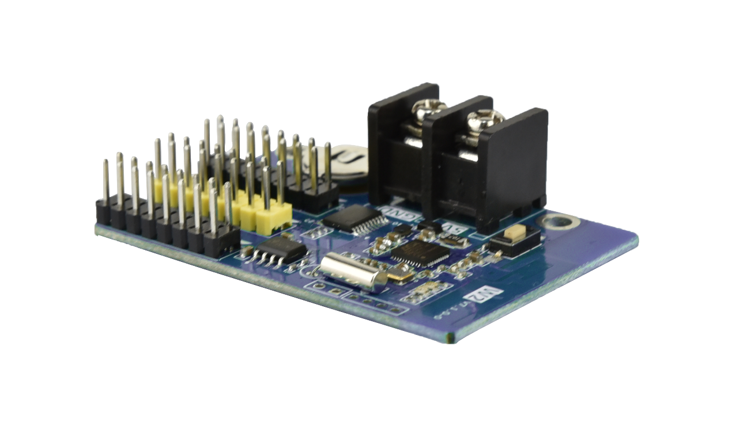

Product Specifications
Single Color Wi-Fi Control Card
HD-W2

V7.1.0

- Overview
W2 is a low cost, high cost-effective single color Wi-Fi controller, easy to operate, better display information, supports variety kinds of single-color display. For the door lintel screen, store screen and other places information display.
Application software: HD2020 and LedArt (APP)

- Connection Demo
The mobile phone and laptop can be connected to the Wi-Fi hotspot of the control card to update the program.
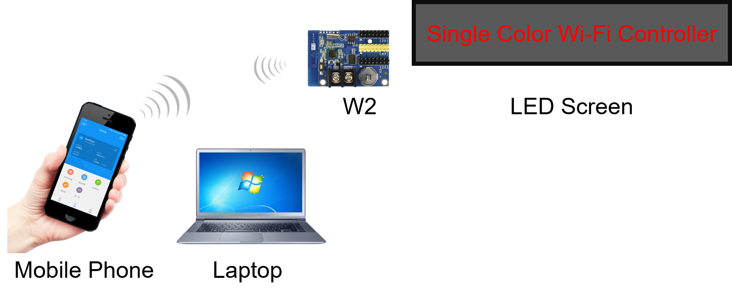
- Product Features
- Wi-Fi on board, support Mobile APP wireless.
- Support program border, regional border settings, custom borders.
- Support DC 2.2V~DC 7V input voltage.
- More than 20 kinds of text effects display.
- Adoption of special RTC chip, effective control of time accuracy.

- Functions List
Control range | Single-color: 512*32, 1024*16
FLASH Capacity | 1M Byte
communication | Wi-Fi
Program Quantity | 1000
Area Quantity | 20areas with separate zone, and separated special effects and border
Display Showing | Text, timing, Count, Lunar calendar
Display | Sequence display
Clock Function | 1.Support Digital Clock, Dial Clock, Lunar Time  2.The Font, size, color and position can be set freely  3.Support multiple time zones
Automatic Switch screen | Support timer switch machine
Dimming | Support two brightness adjustment mode
Power | 3W

- Dimension Chart
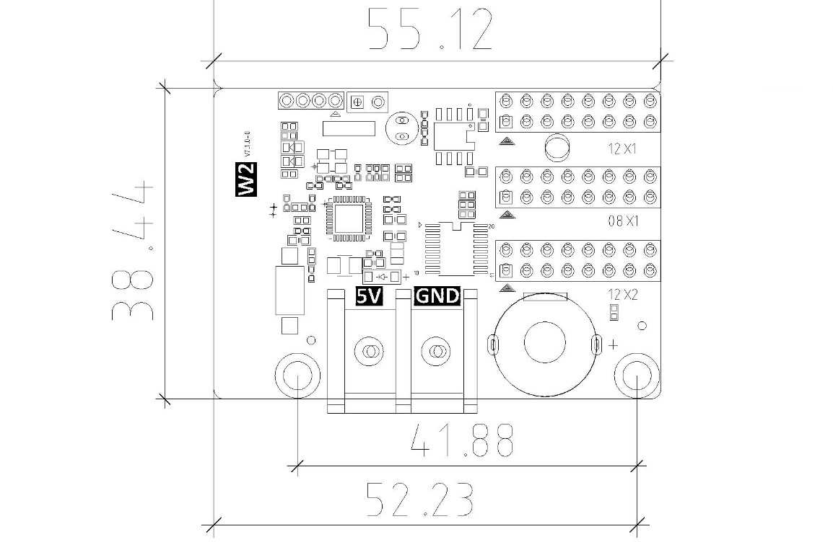

- Interface Description
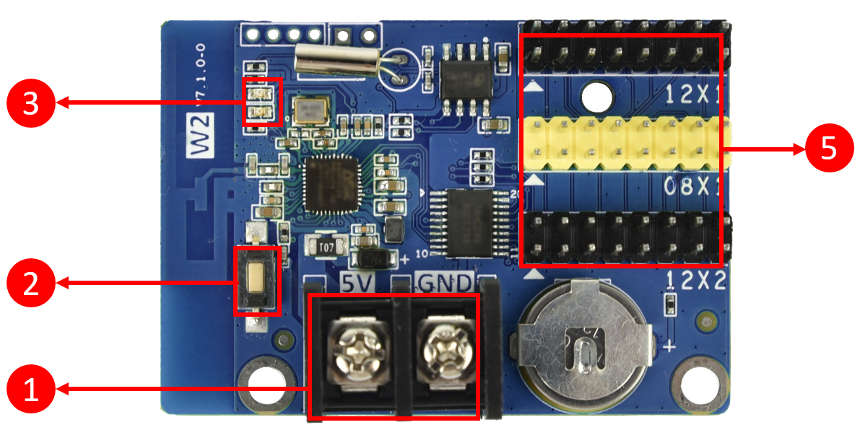
- Power connector, Connect 5V power supply.
- Test button, Click to switch screen test status.
- Indicator: The power on indicator is on and the Wi-Fi working indicator is blinking.
- HUB12 (Black color) & HUB08 (Yellow color): Connect the display.

- HUB12 port Definition
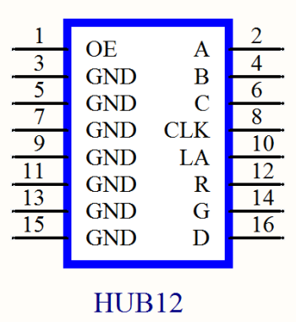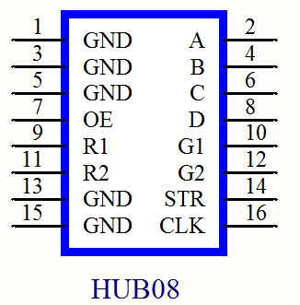
- Basic Parameters
 | Minimum | Typical | Maximum
Rated voltage(V) | 2.2 | 5.0 | 7
Storage temperature(℃) | -40 | 25 | 105
Work environment temperature(℃) | -40 | 25 | 80
Work environment humidity (%) | 0.0 | 30 | 95
Net weight（kg）

Precautions
- To ensure that the control card is stored during normal operation, make sure the battery on the control card is not loose.
- In order to ensure the long-term stable operation of the system, please try to use the standard power supply voltage.

