PRODUCT SPECIFICATION

LED display asynchronous control system
HD-C16L

Version number：V1.0

Update history：
Release version | Release time | Release Notes
V1.0 | September 25th, 2023 | First release

- Product Overview

C16L is a new generation LED multimedia playback card that integrates a sending card, a receiving card and a playback terminal. Compared with the traditional asynchronous playback solution, it can reduce the need for a computer playback terminal, making it easy to control at any time. It has an onboard receiver directly connecting to the screen, which is relatively more cost-effective; It supports the playback of videos, pictures, Gif animations, texts, WPS documents, tables, clocks, timings and other program contents; It supports 60Hz frame rate output, smooth word movement and remote control of power supply and other functions .
C16L comes standard with Wi-Fi and supports mobile APP - "LedArt" wireless control; It supports access to the "XiaoHui Cloud" platform to easily realize remote cluster management on the Internet; It supports USB interface to update programs; It supports external various environmental monitoring sensors, achieving real-time viewing of environmental monitoring data; C16L is widely used in smart commercial displays and smart city fields, such as light pole screens, door screens, vehicle screens and other advertising and display fields.

- Product Features

Input：
1. Support 1 channel 100M communication network port, used for debugging parameters, sending programs and accessing the Internet;
2. Support 1 channel USB communication interface, which can be used to update programs and expand capacity;
3. Support 1 channel dedicated interface for temperature sensor, 1 channel dedicated interface for GPS sensor and 1 channel universal sensor input interface.

Output：
1. The maximum control range is 650,000 pixels, one card can load 200,000 pixels, and a cascade can load 650,000 pixels; the maximum width is 8192 pixels (width > 1920 triggers discount), and the maximum support is 1920 pixels;
2. Comes standard with 1 channel Gigabit output network port, which can be directly cascaded to the HD-R series receiving card to control the display;
3. Onboard 12 sets HUB75E interfaces;
4. 1 channel TRS 3.5mm standard two-channel audio output.
Functions：
1. Comes standard with 2.4GHz Wi-Fi and supports mobile APP wireless control (supports WiFi-AP, WiFi-STA mode);
2. Onboard 1-channel relay can remotely control the power supply;
3. Supports 2-channel video window playback (supports up to 2 channels of 1080P);
4. Support 4G access to XiaoHui Cloud platform to realize remote management on the Internet (optional);
5. Support UART communication;
6. Supports 1 channel RS-232 or RS-485 communication (optional).

- Interface Description

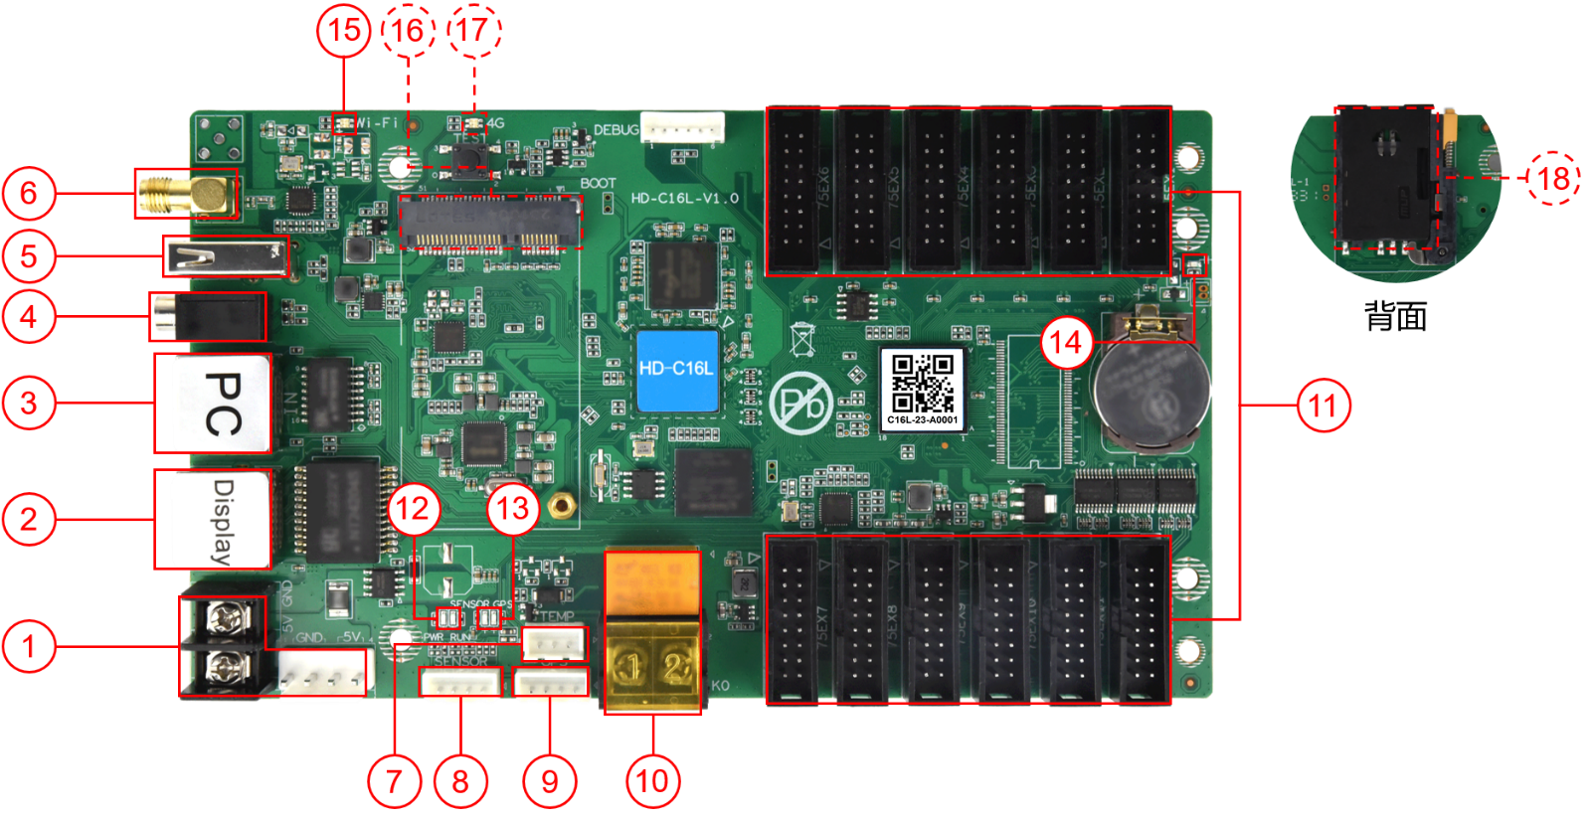

Serial number | Name | Description
1 | Power input terminal | DC 5V（4.6V~5.5V） 3A
2 | Output network port | Gigabit output network port, cascaded with HD-R series receiving cards
3 | Input network port | 100M input network port communication, connect to computer to debug and publish programs, used to access LAN or Internet
4 | Audio output | TRS 3.5mm standard two-channel audio output port
5 | USB | Used to update programs or expand capacity
6 | Wi-Fi antenna | Connect Wi-Fi antenna to enhance wireless signal
7 | Temperature sensor dedicated interface | Connect a temperature sensor to monitor the surrounding environment temperature in real time
8 | Sensor interface | External temperature, humidity, brightness, wind speed, wind direction, noise, PM2.5, PM10, CO₂and other sensors
9 | GPS interface | Connect to GPS module for positioning and time adjustment
10 | Relay | Relay on/off, supports maximum load: AC 250V~3A or DC 30V-3A  The connection method is as follows:  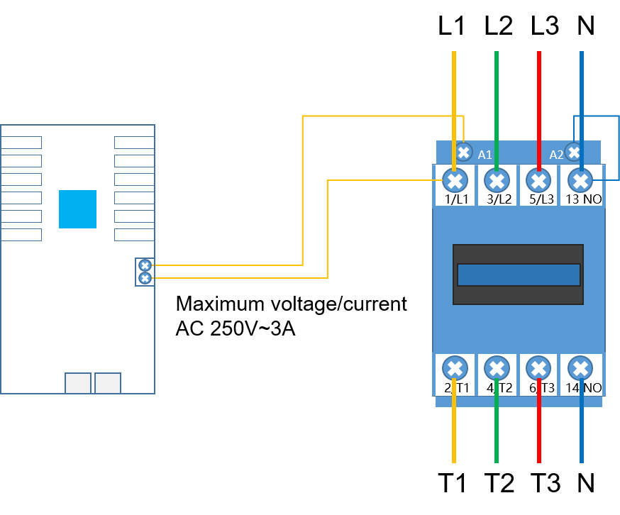
11 | HUB75E interface | Connect HUB75 (B/D/E) interface module
12 | System indicator light | PWR: Power indicator light, green light is always on, power input is normal  RUN: System running light. If the green light flashes, the system is running normally; if the green light is always on or off, the system is running abnormally.
13-1 | Sensor indicator light | ① When detecting that no sensor is connected, the light does not light up;  ②When detecting that a sensor is connected, the green light is always on.
13-2 | GPS indicator light | ① When detecting that there is no GPS signal, the light does not light up;  ②When the GPS star search number < 4, the green light flashes;  ③When the GPS star search number >= 4, the green light is always on.
14 | Display indicator light | If the green light flashes, the FPGA system is running normally; if the green light is on or off, the system is running abnormally.
15 | Wi-Fi indicator light | AP mode:  ①The AP mode is normal and the green light flashes;  ②The module cannot be detected and the light does not light up;  ③Cannot connect to the hotspot and the red light flashes;  STA mode:  ①STA mode is normal and the green light is always on;  ②The bridge cannot connect to the Wi-Fi hotspot and the red light is always on;  ③Unable to connect to the server, the yellow light is always on.
16 | PCIE-4G socket | 4G module socket (optional function, installed with 4G antenna by default)
17 | 4G communication indicator light | ①The green light is always on, and the connection to the cloud server is successful;  ②The yellow light is always on and cannot connect to the cloud service;  ③The red light is always on, there is no signal or the SIM is in arrears or cannot dial;  ④The red light flashes and the SIM cannot be detected;  ⑤The light does not light up and the module cannot be detected.
18 | SIM card holder | Used to install 4G data card and provide networking function (optional, supports optional eSIM card)

- Size Parameters
Size（mm）：
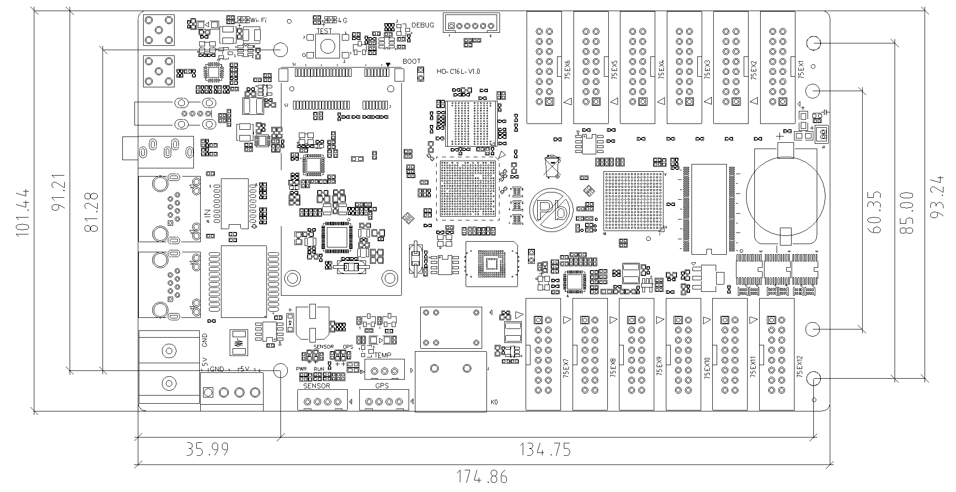
Tolerance: ±0.3 Unit: mm

Product specifications:
Program schedule | Supports sequential playback of multiple programs, timed playback, program insertion, and multi-screen synchronization
Program partition | Support any partition of program window
Video format | AVI, WMV, MPG, RM/RMVB, VOB, MP4, FLV and other common video formats  Supports up to 2 channels of 1080 video playback at the same time
Image Format | BMP, GIF, JPG, JPEG, PNG, PBM, PGM, PPM and other common image formats
Audio format | MPEG-1 Layer III, AAC, etc.
Text display | Single line text, static text, multi-line text, animated words, WPS, etc.
Clock display | RTC real-time clock display and management
U disk | Plug and play
The parameter:
Electrical parameters | Input power | DC 5V（4.6V~5.5V）
 | Maximum power consumption | 8W
Hardware parameters | Hardware performance | 1.5GHz, Quad-core CPU, Mali-G31GPU  Support 1080p@60fps hard decoding playback  Support 1080p@30fps hardware encoding
Storage | Internal storage | 4GB (2G available)
Storage environment | Temperature | -40℃～80℃
 | Humidity | 0%RH～80%RH (no condensation)
Working environment | Temperature | -40℃～80℃
 | Humidity | 0%RH～80%RH（no condensation)
Packaging Information | Checklist:  1×C16L  1×WiFi antenna  1×certificate  Note: 4G antenna comes with 4G module optional 1PCS
Size | 174.9mm×101.4mm
Net weight | 0.14KG
Protection level | The bare board is not waterproof, prevent water from dripping into the product, and do not get the product wet or rinsed
System software | Linux4.4 operating system software  FPGA software

- Way of Communication
1. Stand-alone control, supports Wi-Fi, network port direct connection, and USB interface for communication.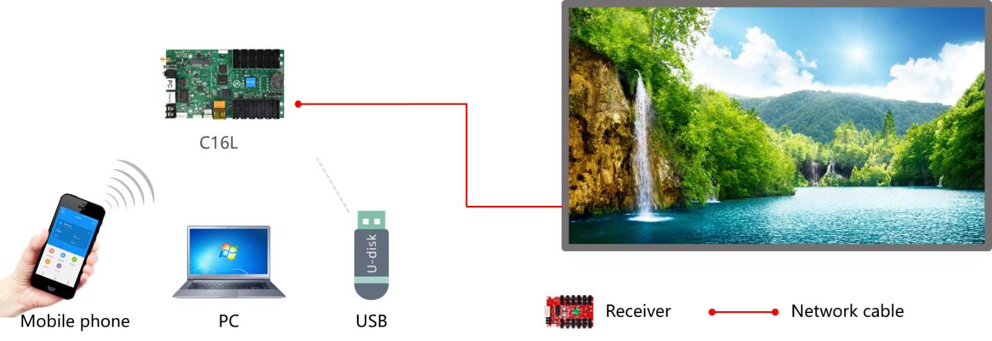

2. Cluster control, supports Internet remote control.
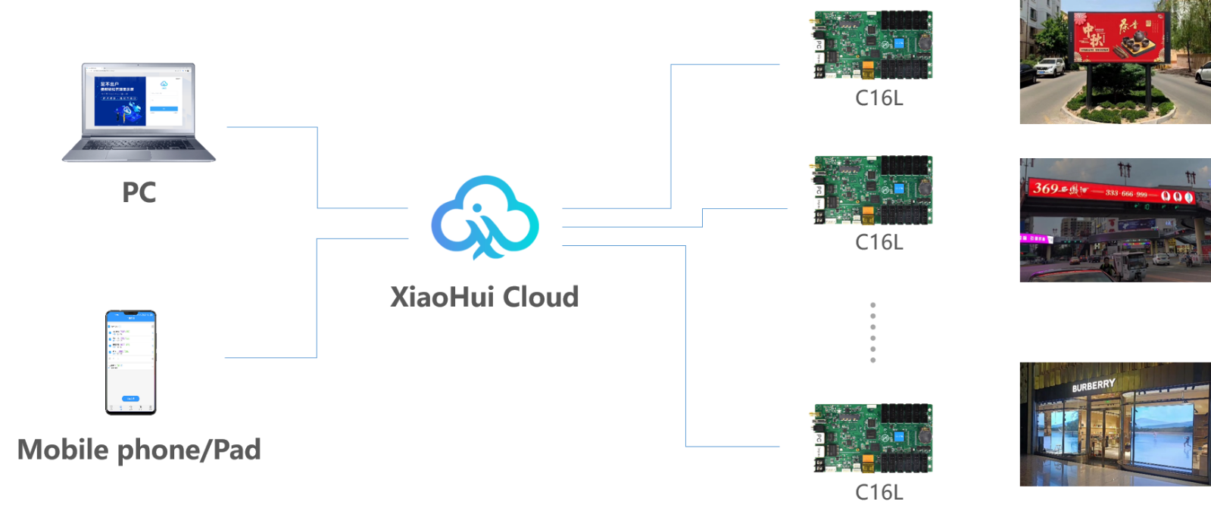

- Appearance
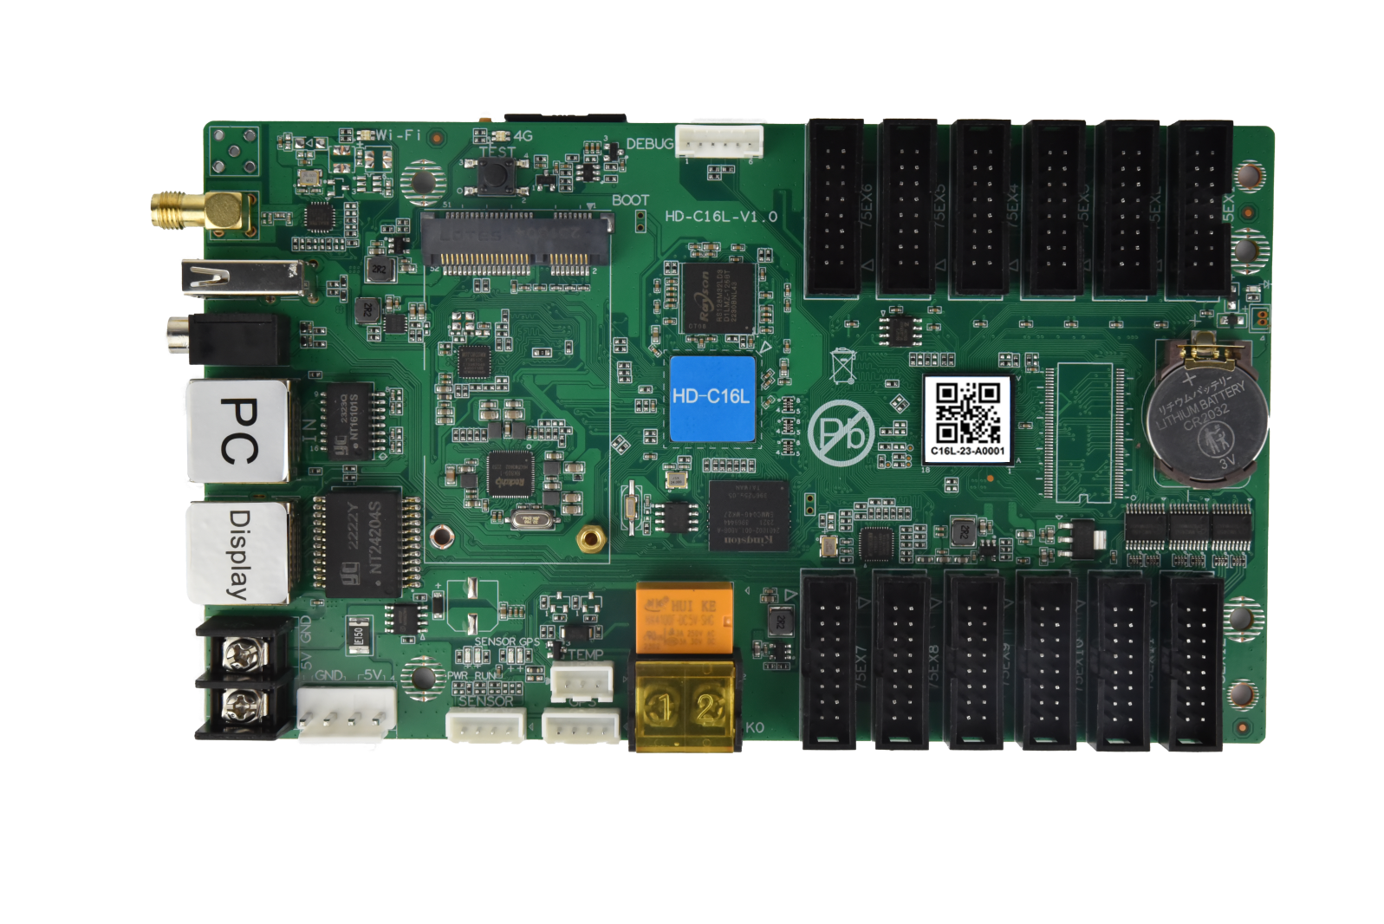
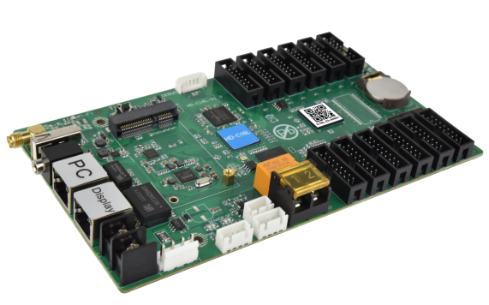
Illustrate:
Welcome to choose Huidu Technology products. There may be differences between the product pictures in the specification and the actual appearance (such as interface caps, antenna installation, etc.). Please refer to the actual product. If you have any questions, please contact technical support or salesperson for confirmation.

